+++ TEACHING GUIDE +++
MODULE 2: PAINTING WITH THE MOUSE

Agenda:
- Opening the MS Paint application (5 min)
- Choosing different brushes and tools (25 min)
- Drawing and erasing - undoing mistakes (25 min)
- Saving your creation (5 min)

[The instructions the learners are given for this module have been designed to clearly describe the actions they should take. Words and phrases that you may take for granted, like “double-click” or “edit-undo”, may be completely new to some learners. When giving instructions, try to use basic descriptions free of any tech/computer jargon. These phrases will be adopted naturally as learners become more familiar with using the computer.

Throughout this module, you’ll want to be going around the lab/room to check in on all the learners to see if they’re having any trouble following along.

If you have access to a projector, demonstrate the actions as you read the instructions. Then allow them to try it themselves on their computer.]

Opening an application
[To prep for this module, it will be best to place a shortcut to the Paint application on the desktop. This will make it easier to find and open for learners who a very new to computers. Some learners may be familiar with double-clicking to open an application, but the instructions they are given suggest single click to highlight the icon then pressing Enter to open.]

On the Desktop (the main computer screen when no applications are open), look for the Paint application.
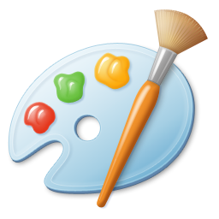
Move your mouse arrow over the icon and press the left button on the mouse once, so it becomes highlighted. Then press the Enter key on the keyboard to open the application.

Choosing different brushes and tools
[This section is to get learners familiar with clicking and dragging the mouse. It may be necessary to emphasize that learners must hold down the mouse button.

Suggest things they can draw like a flower, or a tree or a stick figure.

If students move quickly through the different brushes and colors, introduce the paint bucket/fill tool and the various shape tools.]

Now that the application is open, move your mouse arrow so it is over the white canvas. Press down the left mouse button and hold it down as your move your mouse arrow around the canvas. You should see a black brush stroke appear wherever you moved the mouse.

Choosing a different size brush
[This section is to get learners familiar with drop-down menus and choosing different options from the menu.]

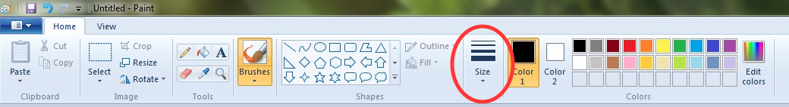
The menu bar
At the top of the application is the menu bar. This allows your to choose different tools and colors to paint with. Look for the icon that says “Size”. Click on the icon with the left mouse button. The menu should now show different size lines. Choose a thick line and try drawing on the canvas with your mouse again to see the results.

Choosing a different color
[Learners should be selecting from the existing color choices. A more advanced exercise is to have them click on “edit colors” and choose a custom color.]

In the menu bar at the top, to the right of the “Size” icon, you will see grid of colors. You can change the color of your brush by clicking on a different color. Choose a color and try “painting” on that canvas again with your new color. Try a few combinations of different colors and different sizes.

Trying new paint tools
[There are plenty of different brush tools. However, if the learners are doing very well, now is a good chance to introduce the other tools Paint has to offer. The built-in shape functions are a good place to start. The paint bucket/fill tool is also a good one to introduce for learners who are comfortable exploring more menus.]

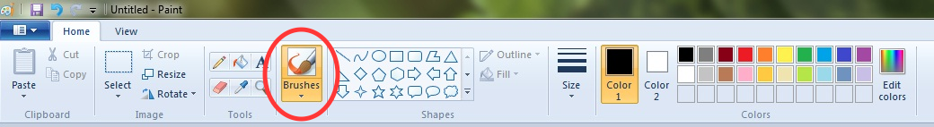
In the menu bar, look for an icon that says “Brushes”. Click with the left mouse button where it says “Brushes” and has the down arrow below it. A drop-down menu of options should appear. These are different “brush styles”. You’ll see options for an “oil brush”, “calligraphy pen”, “crayon”, “spray can”, and others. These different tools will change the types of marks you make when you click and drag (or “paint”) on the canvas below. Select one of these brush types and then “paint” on the canvas below.

Experiment with different brushes, colors, and sizes.

Drawing and erasing
[This section introduces the “Eraser” tool. However, for a more advanced group you could introduce the other way to erase brush strokes: Undo. Have them click on the curved blue arrow in the upper left right next to the “save” icon. Encourage them to try clicking “undo” and “redo” arrows to get comfortable with their functions. (Since the mouse and menus are the focus of this lesson, introducing “Ctrl-Z” as a way to “undo” isn’t recommended yet.)

If students are grasping all this easily, introduce “starting fresh” by clicking File->New and starting with a blank canvas.]

By now, you should have a canvas filled with lots of colorful marks of various sizes. Maybe you think your canvas is very messy and you would like to clean it up.

In the menu bar at the top, look for the icon that is a pink rectangle just below the yellow pencil. This is the “Eraser” tool. Click on that icon with your mouse. Now use your mouse, just like before to “paint” on the canvas. This time you should see your previous marks getting erased. You can also change the size of the eraser to clean up your canvas much faster.

Erase your whole canvas and start drawing something new. With your mouse, click on the Brushes icon again and select the brush tool you like.

Try writing your name with each letter as a different color. If you make a mistake, click on the eraser icon again to erase the things you don’t like.

Saving your creation
[It’s a good idea to make sure the default save location is the desktop so it’s easy for the learners to find their file again once they save and close the Paint application.

Emphasize that each new drawing must have a unique file name. If time allows, encourage them to save a few drawings so they become comfortable with opening, saving, and closing the application.]

When you are happy with the drawing you’ve made, it’s time to save it.

Saving a file in the Paint application is very similar to saving a file in almost any application.
In the top left corner of the application, look for the word “File” (it might just blue button with a down area). Click on it and you should see a menu of options appear. Click on “Save”.
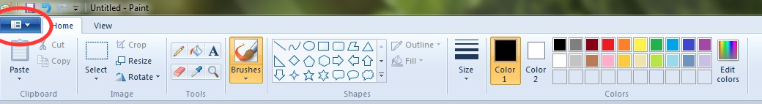

Now a box should appear which will allow you to choose a name for your drawing, and to choose a location on the computer where you want to save it. Use the keyboard to type your name. Once you have typed a name for your drawing, click Save.

Once you’ve saved your drawing you can close the Paint application. You can do this by finding the red ‘X’ in the top right corner of the application and clicking on it.

Exercise: Drawing with Paint
[You can set limits on how long learners should spend on the exercise depending on how much time/access they will have to the computer lab. Find some simple but interesting MS Paint creations to provide inspiration:

http://bit.ly/2lmDQdC
http://bit.ly/2lOih6T
http://bit.ly/2hjeAVb
]

Use several of the techniques you just learned to make something original with the Paint application. Draw a face, or a landscape scene with trees and flowers, or a city building with windows, doors and a garden. Those are just some ideas to get you started. Feel free to paint whatever you like. Just be sure to use different colors, brush types and brush sizes to make your painting come to life!

Save your file on the desktop. You’ll share your creation with the group at the beginning of the next session.

